Trillian to Go
This is a tutorial on how to make your Trillian run on any Removable Media. This includes CD's and USB Drives.
I do not recommend this tutorial for pure beginners. I will expect that the people using this will have basic Trillian Knowledge, including how to install Trillian, where user folders are, and how to install skins and plugins. If you are going to use the Pro version of Trillian I will also expect that you know where to find cracks and how to apply them.
Installing a second Copy of Trillian
1. You need to install a second copy of Trillian to modify for your Trillian to Go. Dowload and begin installing Trillian to a new directory. I have chosen my Desktop for easy access.
2. When installing there are three options to be sure are unchecked: "Add to Desktop" "Add to Start Menu" and "Add uninstall information to Registry"
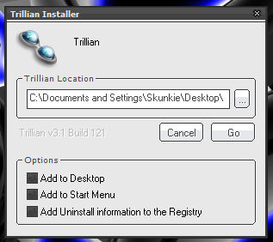
3. When the installer has finished let it launch Trillian. When it asks you if you would like to use Basic or Pro hit cancel.
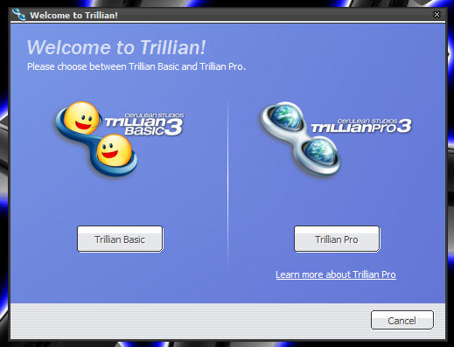
4. Apply your patches for cracking after Trillian has closed.
Installing Extras
1. Now is the time where we will install all the extra skins and plugins. If you are happy just using Whistler and do nto need any plugins then you may skip this part. (Please note that for Trillians running off CD plugins that need to write to files cannot be used. Example: My Stuff)
2. I have chosen to use the Skin: Inspirat 3.0 Black Glass and Plugins: CabrioMeter 3.0 MyChats 2.0.
Configuring Trillian
1. Now is the time where we will congiure Trillian. It is just like any other tie you ahve isntalled Trillian. Go to Trillian Preferences and begin. There will be some things that we will ahve to disable.
2. Installation and Startup: Everything on this Menu should be disabled.
3. Identities and Connections: Set up each of the connections you would like to use (if some of the connections require a plugin please be sure to set that upfirst and then come back to this section) Connect to each medium at least once before continuing.
4. Away Mode: You may chnage any of these preferences you want. If you would like custom away messages create them now, once you have your Trillian on CD you will not be able to edit or create new ones.
5. Contact List: Set the options anyway you like. Be sure Use Pictures to Represent Contacts is Disabled. For users using Trillina on CD will nto be able to use this feature.
6. For CD Users Audio and Video will not work.
7. For CD Users File Transfer will not work. For USB Drive users wait till the file editing section of this transfer.
8. Activity History: For CD users please disable all options. For USB drive users, please set the the options you want logged but wait till the file editing section for where log files will be kept.
9. Skins and Plugins: Choose the skin you would like to use. Choose and setup your pugins now.
Copying Your Profile
1. Locate your profile n your original Trillian Directory. Trillian\users\default (unless you have a different account set up) Copy buddies.xml to the new Trillian installation we have made for Trillian to Go and place it in the users\default folder.
Editing Files
1. Find Trillian.ini in the Trillina root folder and edit:
Code:
[General]
Global Directory=C:\Documents and Settings\Skunkie\Desktop\Trillian\users\global\
to:
Code:
[General]
Global Directory=.\users\global\
2. Find Trillian\users\default\Trillian.ini and open it. Find:
Code:
skin=C:\Documents and Settings\Skunkie\Desktop\Trillian\skins\inspirat_b lack_glass.tsz
The end will show whatever skin you have decided to use for Trillian. Edit this to:
Code:
skin=.\skins\inspirat_black_glass.tsz
3. For USB Dive users find Trillian\users\default\talk.ini and open it.
Find:
Code:
Directory=C:\Program Files\Trillian\users\default\logs
Edit:
Code:
Directory=.\users\default\logs
Find:
Code:
Directory=C:\Documents and Settings\Skunkie\Desktop\Trillian\users\default\do wnloads
Edit it to:
Code:
Directory=.\users\default\downloads
This is where transfered files will go on your USB Drive.
4. Find plugins.ini in Trillian\users\global open it and edit each line with a directory, example:
Code:
[Plugins]
Number=8
Plugin00 Filename=C:\Documents and Settings\Skunkie\Desktop\Trillian\plugins\av.dll
Plugin00 Enabled=1
Plugin00 NoLoad=0
Plugin00 GUID={66369254-9619-4cc8-8F34-07CFBBBD720D}
Plugin01 Filename=C:\Documents and Settings\Skunkie\Desktop\Trillian\plugins\aim.dll
edit all lines with directories like this example:
Code:
[Plugins]
Number=8
Plugin00 Filename=.\plugins\av.dll
Plugin00 Enabled=1
Plugin00 NoLoad=0
Plugin00 GUID={66369254-9619-4cc8-8F34-07CFBBBD720D}
Plugin01 Filename=.\plugins\aim.dll
5. Do the same this as #4 to Trillian\users\default\plugins.ini and Trillian\plugins.plugins.ini
6. I am sure you understand the process by now. Check any ini's in the Trillian directory and user directories. If a line has a directory being pointed to and it does not begin with a .\ then change it to be so. the .\ will trplace anything before a directory that is in Trillian.
C:\Program Files\Trillian\users\default
C:\Program Files\Trillian\plugins
will always turn into:
.\users\default
.\plugins
These are relative paths.
Finished!
That's it. Burn it on CD or transfer it to your USB drive
Extra Option for CD Users
If you would like to have Trillian auto run when you stick the CD into a PC follow these steps:
1. Create a new text document (.txt) open it up and edit.
2. Make the text read:
Code:
[autorun]
open=trillian.exe
icon=trillian.exe
3. Save
4. Rename the txt to autorun.inf
5. Burn this file in the root of the cd.
DONE!

Tutorial by Skunkie!!!!

